Project Design Phase-II
Technology Stack (Architecture & Stack)
Date | 02 October 2026
Project Name | Automated Network Request Management in ServiceNow
Maximum Marks | 4 Marks

Technical Architecture:
The architecture is centered on the ServiceNow cloud platform. The requester accesses the Network Request service through Service Portal and Service Catalog. Catalog variables and configured form behaviour capture the required request information. Flow Designer receives the submitted Requested Item context, retrieves the catalog variables, creates the configured operational record, sends the request for approval, evaluates the approval result, updates the record and sends lifecycle notifications. Roles and ACLs provide access control, while Flow Designer execution details and platform debugging outputs support troubleshooting.
Architecture / Workflow Diagram
Revised for clear separation of workflow stages, decision branches and supporting ServiceNow capabilities.
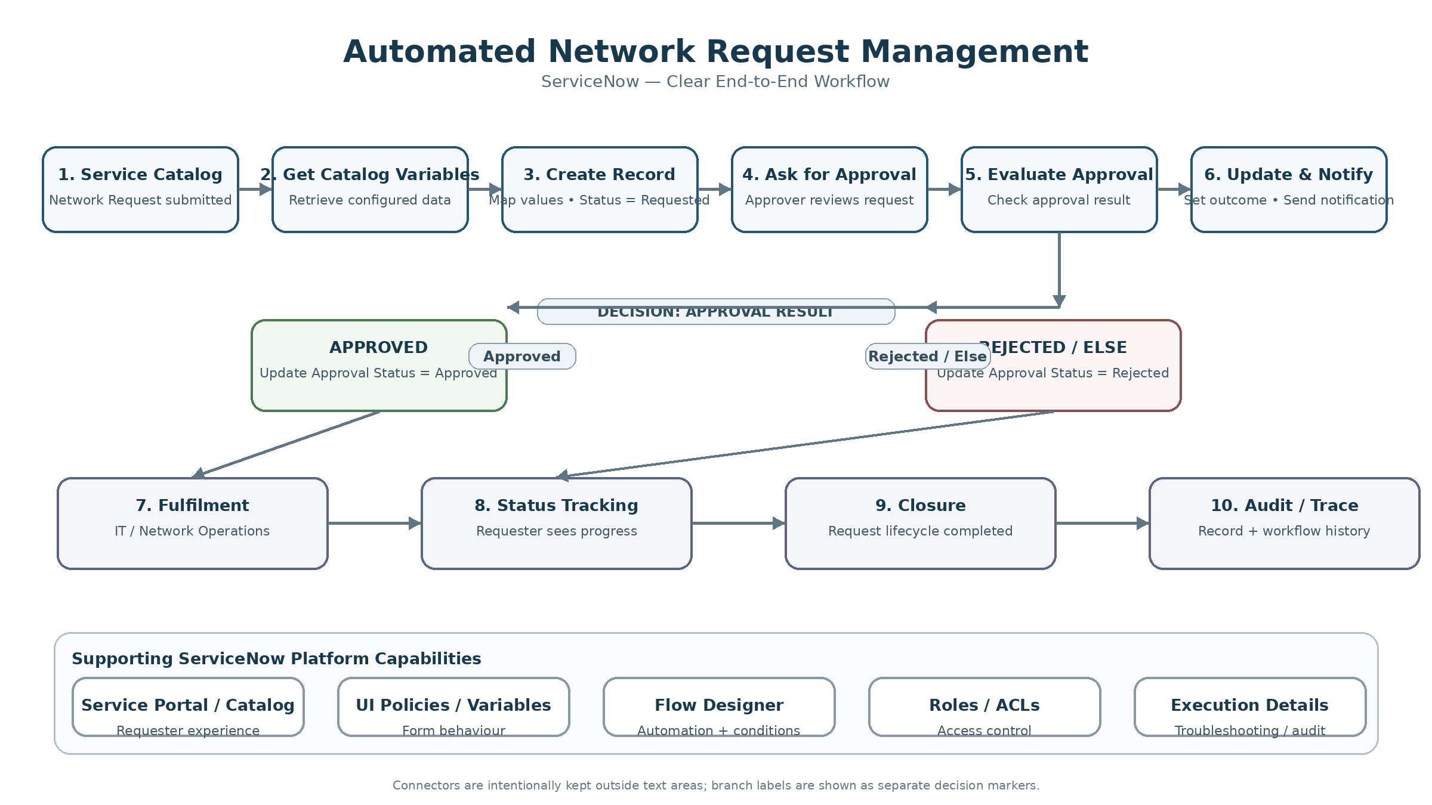
Infrastructure Demarcation
• Cloud / Platform: ServiceNow cloud instance (Personal Developer Instance during development/training).
• Client side: Web browser accessing Service Portal; no separate native mobile application is required for the documented solution.
• Application logic: ServiceNow configuration and low-code automation, primarily Service Catalog, UI Policies, catalog variables and Flow Designer.
• Data storage: ServiceNow Request / Requested Item records plus the configured operational record used by the current implementation.
• External interfaces: No production network-device API, payment gateway, SMS, WhatsApp or third-party integration is claimed as implemented in the current version.
Table-1: Components & Technologies
S.No | Component | Description | Technology
1 | User Interface | Requester-facing submission and request-status experience. | ServiceNow Service Portal; Service Catalog; catalog variables
2 | Form Behaviour | Guided form experience, visibility and mandatory-field behaviour. | ServiceNow UI Policies; Catalog Client Scripts where required
3 | Request Data Capture | Structured network-request information used by downstream automation. | Service Catalog variables; mandatory fields; configured catalog-item structure
4 | Workflow Automation | End-to-end orchestration of request processing, record creation, approval and branching. | ServiceNow Flow Designer; triggers; actions; conditions
5 | Approval Management | Approval request, decision capture and approved/rejected branching. | Flow Designer Ask for Approval; approval rules; approval status condition
6 | Operational Data | Structured record created and updated from submitted catalog values. | ServiceNow configured operational table / record; current implementation visibly uses the configured Database Tables record
7 | Platform Records | Native request context generated from Service Catalog submission. | ServiceNow Request / Requested Item (REQ / RITM) records
8 | Notifications | Request-created and resolution/status communications. | ServiceNow Flow Designer Send Email action / configured notifications
9 | Security | Controlled access to request and operational information. | ServiceNow Roles; Access Control Lists (ACLs)
10 | Diagnostics | Trace flow execution, mappings, conditions and failures. | Flow Designer Execution Details; platform logs / debugging outputs
11 | File Storage | No separate application file-storage service is required by the documented core flow. | ServiceNow-managed platform storage as applicable
12 | External API / Integration | Future integration point for network systems or external notification/services. | Not implemented in current version; integration can be added as future scope
13 | Machine Learning Model | No ML inference or model dependency is required by the current workflow. | Not applicable to the current version
14 | Infrastructure (Server / Cloud) | Application execution and hosting environment. | ServiceNow cloud instance / Personal Developer Instance for development and training
Technology Flow
Browser → Service Portal → Network Request Catalog Item → Catalog Variables / UI Policies → Flow Designer → REQ/RITM + Configured Operational Record → Approval → Record Update → Notification → IT / Network Operations.
Table-2: Application Characteristics
S.No | Characteristics | Description | Technology / Design Choice
1 | Open-Source Frameworks | No separate open-source application framework is required by the documented core implementation. | ServiceNow platform components; no specific external framework asserted
2 | Security | Protect network-request records and administrative capabilities according to user role; enforce controlled read/write access. | ServiceNow roles, ACLs and platform authentication/session controls
3 | Scalable Architecture | Configuration-driven design permits additional request categories, variables, approval rules and fulfilment paths without replacing the complete solution. | ServiceNow modular Service Catalog + Flow Designer + configured record design
4 | Availability | Application availability follows the availability of the deployed ServiceNow instance and related platform services. | ServiceNow-managed cloud platform; no separate availability layer
5 | Performance | Minimize unnecessary client scripting and use Flow Designer for maintainable server-side orchestration; validate variable mapping and workflow execution for normal request scenarios. | ServiceNow workflow execution + lightweight portal/client configuration
6 | Maintainability | Use configuration-first components and document the setup so another administrator can reproduce or modify the solution. | Service Catalog, Flow Designer, UI Policies, ACLs and documented configuration
7 | Observability / Troubleshooting | Trace workflow runs, action inputs/outputs, condition paths and record mappings when failures occur. | Flow Designer Execution Details; platform logs/debug outputs
8 | Compatibility | Ensure the requester experience operates through the intended Service Portal/catalog experience and does not depend on backend-only UI behaviour. | Service Portal + Service Catalog + supported ServiceNow configuration
Implemented vs Future Technology Boundary
• Implemented/documented core: Service Portal, Service Catalog, catalog variables, configured form behaviour, Flow Designer, operational record creation/update, approval handling, condition branching, email notifications, roles/ACLs and execution tracing.
• Future integrations: network-management/device APIs, automated fulfilment integrations, external messaging channels and advanced operational dashboards.
• Not applicable in the current version: a machine-learning inference model and a separately managed application server/database outside ServiceNow.

